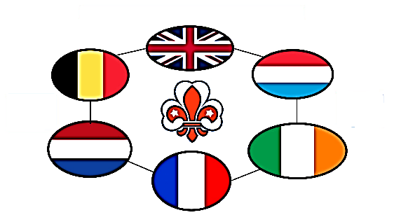
ISGF 28th Western Europe Sub-Region Gathering Sept 2022
AISG 28 ème Rencontre Sous-Regionale de l’Europe de l’Ouest

Hosted by NSGF UK - Présidé par ANSG Royaume-Uni
Innovate, Inspire, Improve – Innover, Inspirer, Ameliorer

To National Scout and Guide Fellowship (NSGF)

Registration form

Please complete and return not later than 1st July 2022

to sue.page3@btinternet.com

Name ..........................................................................................................................

Email : .........................................................................................................................

Country : .....................................................................................................................

Function in NSGF (National President, International Secretary, other or none) :

.....................................................................................................................................

- Want to take part in the 28th WESR Gathering Sunday 11th September 2022
- This gathering will be via zoom and will be recorded

Signed by

................................................ .....................................................
Name Date

