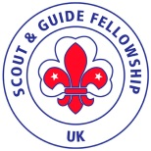
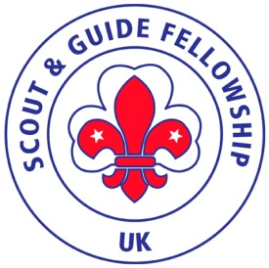

SAGF Annual General Meeting
23rd April 2022

The District Scout Centre in Chester, Arkell Scouting and Community Centre, Upton Grange, Chester
CH2 1BG has offered to be our hosts for our 2022 Annual meeting on Saturday 23rd April . Visitors need to make their own hotel arrangements but we can recommend staying at the Premier Inn 76 Liverpool Rd, Upton, Chester CH2 1AU Phone: 0333 777 4542. This is in the neighbourhood of the District Scout Centre (less than a mile away) which is itself only just over a mile from the city centre. You could leave cars at the hotel (free parking) and go into the centre by one of the frequent buses. However, if you want to be in the city centre, there are two Travel Lodges to choose from. Car parking is always a problem in the city centre, though.
To assist us with the arrangements we would be grateful if you would pre-register your intention to attend. The £10 per person registration fee includes morning coffee and buffet lunch
Proposed Programme for the day
10.30 for 11am start Welcome drink
11.30 Annual meeting
Lunch
Afternoon free to explore Chester, visit the zoo, walk the town walls….
Possible meet up for evening meal. To be arranged when numbers are known.
Name………………………………………………………………………………………
Address……………………………………………………………………………………
Phone number……………………………………………………………………………..
Email………………………………………………………………………………………
No. of persons attending @£10 per person ……………………………………………
Please pay either by cheques payable to Scout and Guide Fellowship UK or
by bank transfer Scout and Guide Fellowship UK Account 76839079 sort code 60 17 21
and if staying overnight indicate if you wish to join us on Saturday evening
Please return to murielcrayner@aol.com or 121, Sundorne Cres , Shrewsbury SY1 4JH
An email acknowledgment will be sent.

